**CCGC 5004 Database Systems**

**Lab Exercise 11 Tables with JSON**

**Overview**

**To receive credit for this lab you must be present in today’s class. Late submissions are deducted 5% per day up to 5 days. Submissions received after 5 days will be given a grade of 0.**

**You will write and execute the required statements as requested in the questions below.**

1. Connect to MYSQL Shell pr as it sometimes shown mysqlsh. This is the MySQL icon on the right not the left.



This will open a session to mysqlsh.

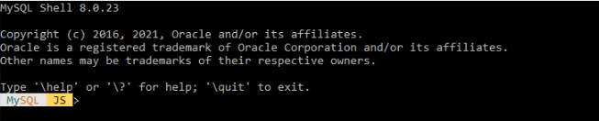

At the prompt you will need to enter a connection string to connect to mysqlsh using the X Plugin for X DevAPI.

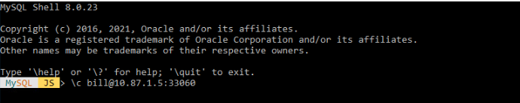

My account name is bill. Yours will be the “N” student number and F22 appended to the number. The IP address is 10.87.1.5 followed by a colon then the port number of 33060. You will be prompted for your first connection a password. It is the same password you connected with in MySQL Workbench. The initial password was Humb3r22@. Enter this password to connect. You will be asked to save this password for future connections.

Once you are connected the prompt will change to reflect your connection.

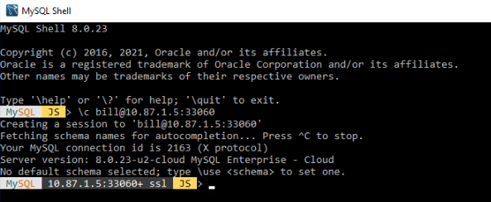

The final step here is to connect to your schema. Ener \use <schema> where schema is your schema name. You will notice the prompt changes to reflect your schema name.

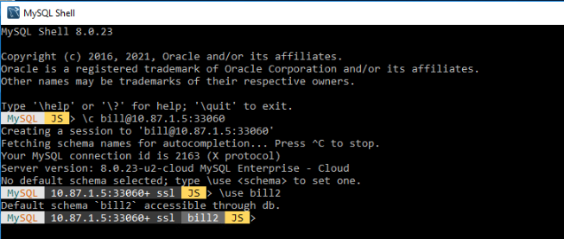

Take a screen capture to show that you are now connected to mysqlsh. (**Screen Capture** 1.)

1. Continue to use the table called MUSIC for the following questions:
2. Using MySQL Workbench create a table called MUSIC with the following details: (**Screen Capture 2**)

ID integer, auto increment, primary key

TITLE character length of 50 Variable

ARTTIST character length of 50 Variable

YEAR RELEASED integer 4

GENRE JSON column with the KEY of GENRE followed by the VALUE for the genre

1. This is the data you inserted to the MUSIC table. (Just showing again)

|  |  |  |  |
| --- | --- | --- | --- |
| TITLE | ARTIST | RELEASE YEAR | GENRE |
| The Roadie | Gary Lucas | 2020 | Folk |
| Chemtrails over the Country Club | Lana Del Rey | 2021 | Pop |
| Zoom In | Ringo Star | 2020 | Pop |
| No Need to Argue | The Cranberries | 1994 | Pop |
| Macca to Mecca | Little Steven and the Disciples of Soul | 2020 | Rock |
| Deeper | Tara MacLean | 2019 | Folk |
| My Savior | Carrie Underwood | 2021 | Country |
| Justice | Justin Bieber | 2021 | Pop |
| McCartney III | Paull McCartney | 2020 | Rock |
| Drastic Fantastic | KT Tunstall | 2003 | Rock |
| Wildflowers and All the Rest | Tom Petty | 2019 | Rock |
| Violet Bent Backwards Over the Grass | Lana Del Rey | 2018 | Pop |
| Fogerty’s Factory | John Fogerty | 2020 | Rock |
| Campfire Chords | The Arkells | 2018 | Rock |
| Western Stars | Bruce Springsteen | 2003 | Rock |
| The Story | Brandi Carlisle | 2009 | Rock |
| We are Young | Fun | 2016 | Rock |
| Gloria | Laura Branigan | 1992 | Rock |
| Fleetwood Mac | Rumors | 1977 | Rock |

The GENRE is to be entered so it entered as a KEY:VALUE. The KEY is GENRE and the value is listed genre value.

1. Select from the records you have entered all titles, artists, where the genre is Folk. Only display the titles, artist and genre columns. (**Screen Capture 2**)
2. Select from the records you entered titles, artists where the genres are either Pop or Rock and the Artist starts with the letter J or B and released after the year 2019. The output is to be sorted the artist’s name is ascending order. (**Screen Capture 3**)
3. Write a statement to show releases between 1990 and 2018. Only show releases that are pop. Sort the result by the year released. Only display the first 2 records. (**Screen Capture 4**)
4. Delete any titles that are in the country genre. (**Screen Capture 5**)
5. Switch to Workbench, display your music table contents. (**Screen Capture 6**)